**Bug fixes**

After the conference, we discovered a minor bug in our code. The bug has been corrected in all the files in this repo. However, if one wanted to run this code and recreate the results in the paper, they might be frustrated as they find the results don’t match up exactly. That is a result of the bug correction. The following document describes all the differences one can expect to find as they run the code with the bug fix. If you have any questions or find any other bugs in the code, feel free to email Will Melville at wmmelville@gmail.com.

**Section 3.2.1.**

The equilibrium strategy for Jansen is to throw the cutter with the same intended location as in the paper but now it’s only 62% of the time instead of 63%. Likewise, the slider location in the equilibrium is unchanged, but the rate is 38% instead of 37%.

Phillips’ best response strategy is to swing 53% of the time now, instead of 54%. The expected utility is still -0.07. The actual pitch utility is still 0.037. Figure 3a does not change noticeably. The only change would be the values of the colors of the points, but since the changes are by 1% in each case, it isn’t a noticeable change.

**Section 3.2.2.**

For figure 3b, all of the pitches are still cutters, but the locations change slightly. Noticeably, the red ‘x’ moves a little bit higher and a little bit more towards the middle.

In the second paragraph of this section, all info remains the same except that the expected utility of the optimal pitch is 0.008 instead of 0.007, and the best possible pitch has an expected run value of -0.066.

**Section 3.2.3.**

It is still the case even after correcting the bug that Jansen’s most likely pitch is that slider below the zone, and Phillips should respond by swinging. The expected run value of swinging at the slider in that decision point is -0.11, not -0.10. The take utility is still 0.05. The swing utility at a sinker or cutter in that decision point is still 0.03, and the take utility is -0.2 and -0.18 for sinker/cutter respectively. So the only one of these values that changed is the run value of swinging at the slider, which is mostly a result of rounding. We round up to -0.11 now instead of rounding down to -0.10.

The plots, figures 3c and 3d, do change somewhat significantly. Perhaps most notably, instead of two sinkers at the bottom of the zone that pass through a similar decision point as the slider below the zone, there are now three sinkers.

Figure 4 also changes. The values on the y axis change, although the message stays the same. Lower swing rate gives worse utility to Phillips.

**Section 8.1.**

The first two paragraphs are all correct after the bug fix. In the third paragraph, the fastball that Altuve has a mixed strategy for has changed locations and the strategy has changed. The strategy is now to swing 44% of the time and take 56% of the time. And instead of being in the bottom middle part of the zone, it is in the bottom and left half of the zone. Thus, Altuve needs to sample from Bernoulli(0.44) instead of Bernoulli(0.12). Naturally, figure 13 also changes after fixing the bug.

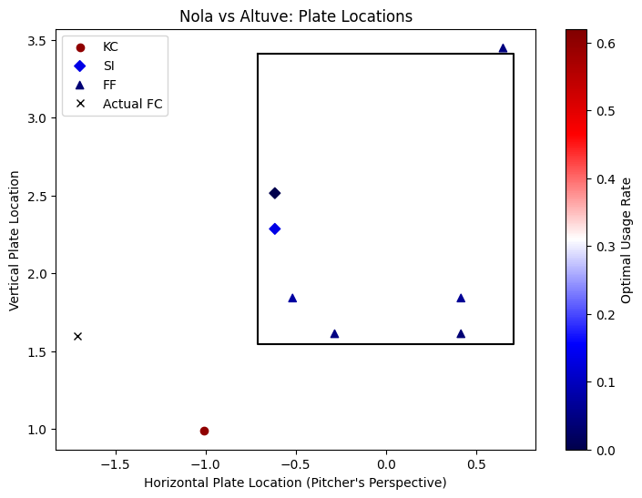

The last paragraph of the section is unchanged, so just the third paragraph and the figure would need to be adjusted.